IFB398 WanderLust - Shorthand

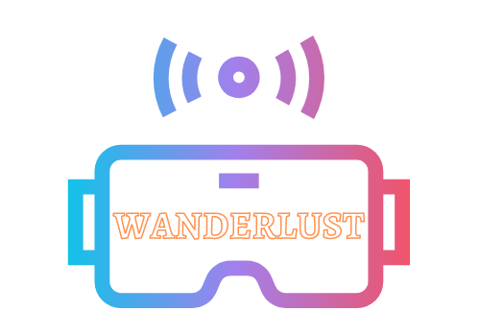 

PROJECT Prototype Guide

## 

## Installation

As this project has been developed using WebXR’s A-Frame, it will not be able to run on normal local protocols (ie file://) due to A-Frame’s *Cross Origin Policy*, and must be run using a proper local server. To host a local server, please use any of the options below:

* Download the Brackets.io open source web designing application, open the prototype directory and run the live preview on the right bar
  + 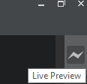
* Download the [Mongoose](https://www.cesanta.com/products/binary) application and open it from the same directory as your HTML file.
* Run python -m SimpleHTTPServer in a terminal in the same directory as your HTML file.
* Run npm install -g live-server && live-server in a terminal in the same directory as your HTML file.

## Interactions:

* Looking at certain elements in the story (the images and the tree object) will slowly scale it up, allowing the user to see it more clearly and notice smaller details of the element.
* The User may move around the story using the WASD or ARROW keys, allowing you to get closer to the images, objects or text for closer inspection for more detail.
* The User may look around the story by left clicking, holding and dragging the mouse around the screen, allowing the user to explore the different areas and angles within the story.

## Story Navigation:

* Pressing “E” or “Q” keys will reset the text animation and show the next/previous section of the story.

For alternate story navigation features:

* Pressing “P” will reset the text animation, and display four paragraphs of text surrounding the User from all angles, providing the opportunity for enhanced immersive story-telling.
* Holding “I” and “K” keys will scroll the front-most text up or down, allowing the User to scroll through the current story section at their own pace.